

Projectile 2017

User Manual

Presented by  
Daniel Liang and Kush Patel

June 16, 2017

Table of Contents

Starting the Program .......................................................................................................................1

General Operation.........................................................................................................................1-2

Default Mode...................................................................................................................................3

Initial Angle Mode...........................................................................................................................3

Initial Speed Mode...........................................................................................................................3

Initial Angle, Initial Speed and Target Distance Mode...................................................................3

Cannon Height Mode.......................................................................................................................3

Error Messages.............................................................................................................................4-5

Known Problems..............................................................................................................................5

Starting the Program

Open the file named Projectile2017.exe.

General Operation

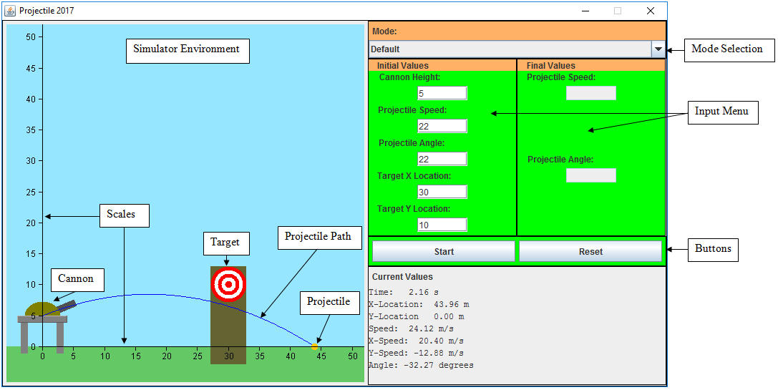

Figure 2.0 The window for the program, with added labels. See below for details.

Simulator Environment

This is the space where the animation takes place. It automatically sizes itself to fit the screen. There is a blue sky, in which the projectile travels and a green grass ground where it can land.

Scales

The horizontal scale shows the distance away from the center of the cannon, where the projectile originates. The vertical scale shows the height off the ground. The scales automatically adjust themselves so that nothing goes off the screen. The scales are in meters.

Cannon

The cannon launches the projectile from its center. The muzzle of the cannon shows the angle the projectile is fired at. It has stilts that raises itself to the required height.

Target

A ring target is attached to the top of a wood pole. In default mode, if the projectile passes close enough to the center, it will stick to the target. In other modes, the projectile lands exactly on the center red dot.

Projectile

An orange dot represents the projectile. It originates in the center of the cannon.

Projectile Path

A blue line shows the parabolic path of the projectile until it lands.

Mode Selection

A drop down menu that is used to select the mode of the simulator. The names of the modes indicate the variables the simulator will solve. The modes are described in more detail in the next sections. It is disabled during animation.

Input Menu

The user inputs data for the projectile simulation in the text fields. All speeds are in meters per second, all angles are in degrees, all distances are in meters. In the initial value fields, greyed out fields mean that the simulator will fill them in when the animation starts, rounded to two decimal places. Distances and speed must be positive values. The angle must be between -90˚ and 90˚ inclusively. The angle is measured from the horizontal at the 3 o’clock position. Negative angle means below the horizontal. The final values fields are not used, except in the fourth mode. The final angle must be between 0˚ and 90˚ inclusively. It is possible to use scientific notation, using the letter E to represent the exponent of 10. For example, 1e3 is the same as 1000, or 1 × 103.

Buttons

The Start button begins the animation and solves variables in greyed out initial value fields. The Reset button clears all input fields and returns the cannon and target to their default locations. During animation, the Start button changes to Pause / Continue. Clicking it will pause or unpause the animation. The Reset button changes to Stop. Clicking it will stop the animation, clear the projectile path and place the projectile back inside the cannon.



Figure 3.0 The buttons during animation.

Current Values

The current values pane, located on the bottom right, shows properties of the projectile in real time as the animation progresses, rounded to two decimal places. Negative Y values means the projectile is going downward. The acceleration is always -9.8 m/s, which is downward. Air resistance is neglected.

Default Mode

In this mode, you will have to provide all the initial values of the projectile. This includes: Cannon Height, Projectile Speed, Projectile Angle, Target X Location, and Target Y Location. During animation, if the projectile passes close enough to the target, it will stick to the target, ending the animation. Otherwise, the projectile continues until it hits the ground.

Initial Angle Mode

In this mode, you will have to provide the values for: Cannon Height, Projectile Speed, Target X Location and Target Y Location. The program will then solve for the Projectile Angle by itself when you start the animation. The angle solved is the smallest initial angle needed to reach the target.

Initial Speed Mode

In this mode, you will have to provide the values for: Cannon Height, Projectile Angle, Target X Location and Target Y Location. When you start the animation, the program will solve for the initial Projectile Speed by itself.

Initial Angle, Initial Speed and Target Distance Mode

In this mode, you will have to provide the values for Cannon Height, Target Y Location, Final Projectile Speed, and Final Projectile Angle. The program will solve for initial Projectile Speed, initial Projectile Angle, and Target X Location by itself after the animation is started.

Cannon Height Mode

In this mode, you will have to provide the values for Projectile Speed, Projectile Angle, Target X Location, and Target Y Location. The program will solve for the Cannon Height by itself after the animation is started.

Error Messages

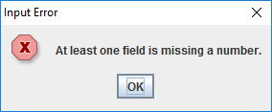

This means that one or more of the required text fields is blank, or contains non-numeric characters. The program can only take numerical data input.

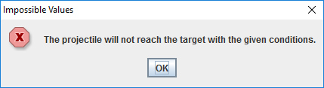

Based on the values inputted by the user, there are no solutions for the variables that the simulator is trying to solve. For example, when trying to solve for initial speed, if the target too high and too close to the cannon and the initial angle is too small, it may not be possible for the projectile to hit the target.

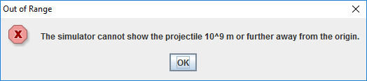

One or more of the values entered will cause projectile values or scale to exceed Java’s maximum variable sizes. Therefore, the simulator cannot work with such large numbers. It also occurs for “Infinity” and “NaN” inputs.

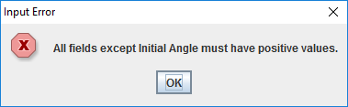

The simulator does not allow any object to go behind the cannon or underground.

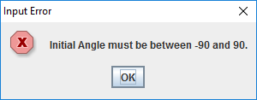

The cannon cannot be pointed behind the vertical scale, because it would cause the projectile to be launched to the left.

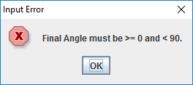

This message is only for the initial angle, initial speed and target distance mode. The simulator only shows the projectile hitting the target at an angle below or equal to the horizontal, so only the magnitude of the final angle is needed. 90 degrees is not a possible value since the projectile cannot get above the target and land straight down.

Known Problems

These are problems with the software that we did not have time to fix or is an issue with Java itself.

* When entering a ridiculously large speed, the text showing current projectile speed causes the input menu and current values to expand and cut off part of the simulator environment.
* If the text in the current values is selected while the animation is running, it may cause the program to hang. The cause of this is unknown.
* If the simulation runs for a ridiculously long time, Java may run out of memory and the program will hang.